EXPERIMENT-2
Generation of Three Address Code (TAC) for an Arithmetic Expression.

AIM:
To write a C program to generate Three Address Code (TAC) for an arithmetic expression using operator precedence.

PSEUDOCODE:
- Start the program.
- Read the arithmetic expression.
- Separate the target variable and the expression.
- Identify operands and operators.
- Check operator precedence.
- Generate temporary variables (t1, t2, etc.) for each operation.
- Print the Three Address Code.
- Stop the program.

Program:
#include <stdio.h>
#include <string.h>
#include <ctype.h>
#define MAX 100
char operators[MAX];
char operands[MAX][MAX];
int otop = -1, vtop = -1, temp = 1;

int precedence(char op) {
if (op == '+' || op == '-') return 1;
if (op == '*' || op == '/') return 2;
return 0;
}
void generate() {
char op = operators[otop--];
char right[MAX], left[MAX], result[MAX];
strcpy(right, operands[vtop--]);
strcpy(left, operands[vtop--]);
sprintf(result, "t%d", temp++);
printf("%s = %s %c %s\n", result, left, op, right);
strcpy(operands[++vtop], result);
}
int main() {
char expr[MAX], target[MAX] = "";
int i = 0, j = 0;
printf("Enter expression: ");
fgets(expr, MAX, stdin);
while (expr[i] != '=' && expr[i] != '\0')
i++;
if (expr[i] == '=') {
strncpy(target, expr, i);
target[i] = '\0';
i++;
} else {
i = 0;
}

printf("\nThree Address Code:\n");

while (expr[i] != '\0') {
if (isspace((unsigned char)expr[i])) {
i++;
} else if (isalnum((unsigned char)expr[i])) {
char value[MAX];
j = 0;

while (isalnum((unsigned char)expr[i]))
value[j++] = expr[i++];

value[j] = '\0';
strcpy(operands[++vtop], value);
} else if (expr[i] == '(') {
operators[++otop] = expr[i++];
} else if (expr[i] == ')') {
while (otop >= 0 && operators[otop] != '(')
generate();

if (otop >= 0) otop--;
i++;
} else if (strchr("+-*/", expr[i])) {
while (otop >= 0 && operators[otop] != '(' &&
precedence(operators[otop]) >= precedence(expr[i]))
generate();

operators[++otop] = expr[i++];
} else {
i++;
}
}

while (otop >= 0)
generate();

if (vtop >= 0 && target[0] != '\0')
printf("%s = %s\n", target, operands[vtop]);
return 0;
}

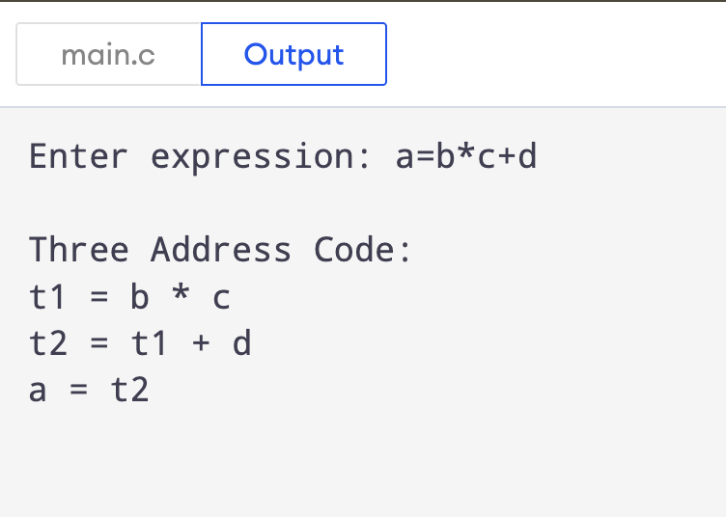
OUTPUT:

RESULT:
Thus, the Cipher Feedback (CFB) mode was successfully implemented in C, and the original plaintext was correctly recovered after decryption.

